**Learner’s Academy Administrator - Specification Document**

**Project Detail**

Project Name: Learner’s Academy

**Project Version: 1.0**

**GitHub repository link:**

**Project Details:** This project is for the design and developing a backend administrative portal for the Learner’s Academy using Java EE technologies

**Objective**: The Objective of this project is to apply servlet, jsp and JDBC concepts.

**Developer Detail**

Name: Neha Gandhi

Batch: JAVA FSD Cohort Aug 22

**Technologies and tools Used:**

* SQL: to create and manage the database.
* JSP: to handle the presentation view.
* JDBC: to make operations on the database for the project.
* HTML: to format the contents.
* Eclipse: to write and run the code.
* Tomcat: to run and deploy servlet application.

**Flow Chart:**

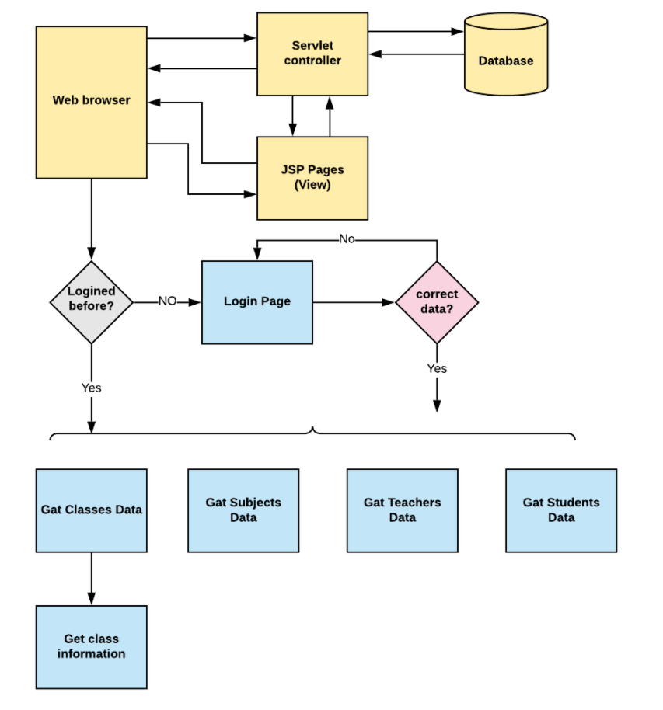

**Sprint Plan:**

**Sprint 1:**

1. Create databases and tables.
2. Connect the database to the project.
3. Create models classes.
4. Create a database utility class to retrieve data.
5. Create the login page.

**Sprint 2:**

1. Create JSP files for all pages of the project.
2. Create DAO files to connect jsp and java files.
3. Debug and Test the project.

**Concept used in this programme:**

1. HTML : To design appearance.
2. Object-Oriented: used to create and model objects for users and their credentials.
3. Databases: used to store and retrieve data.
4. Data Sources: used to define a set of properties required to identify and access the database.
5. Collections: used some collections like arraylist to store collection of data types.
6. Exception Handling: used to catch problems that arise in the code especially in I/O blocks.
7. Cookies: to store log-in data on the client browser. Searching and Sorting

**How to run the program:**

1. clone project
2. Import the “database\database.sql” file to your database administration tool.
3. Go to “\src\main\webapp\META-INF\context.xml” file and open it.
4. Edit the database’ properties such as username, password and driverClassName as per your database administration tool.
5. Run the program on server.
6. To login you must enter admin for both username and password.